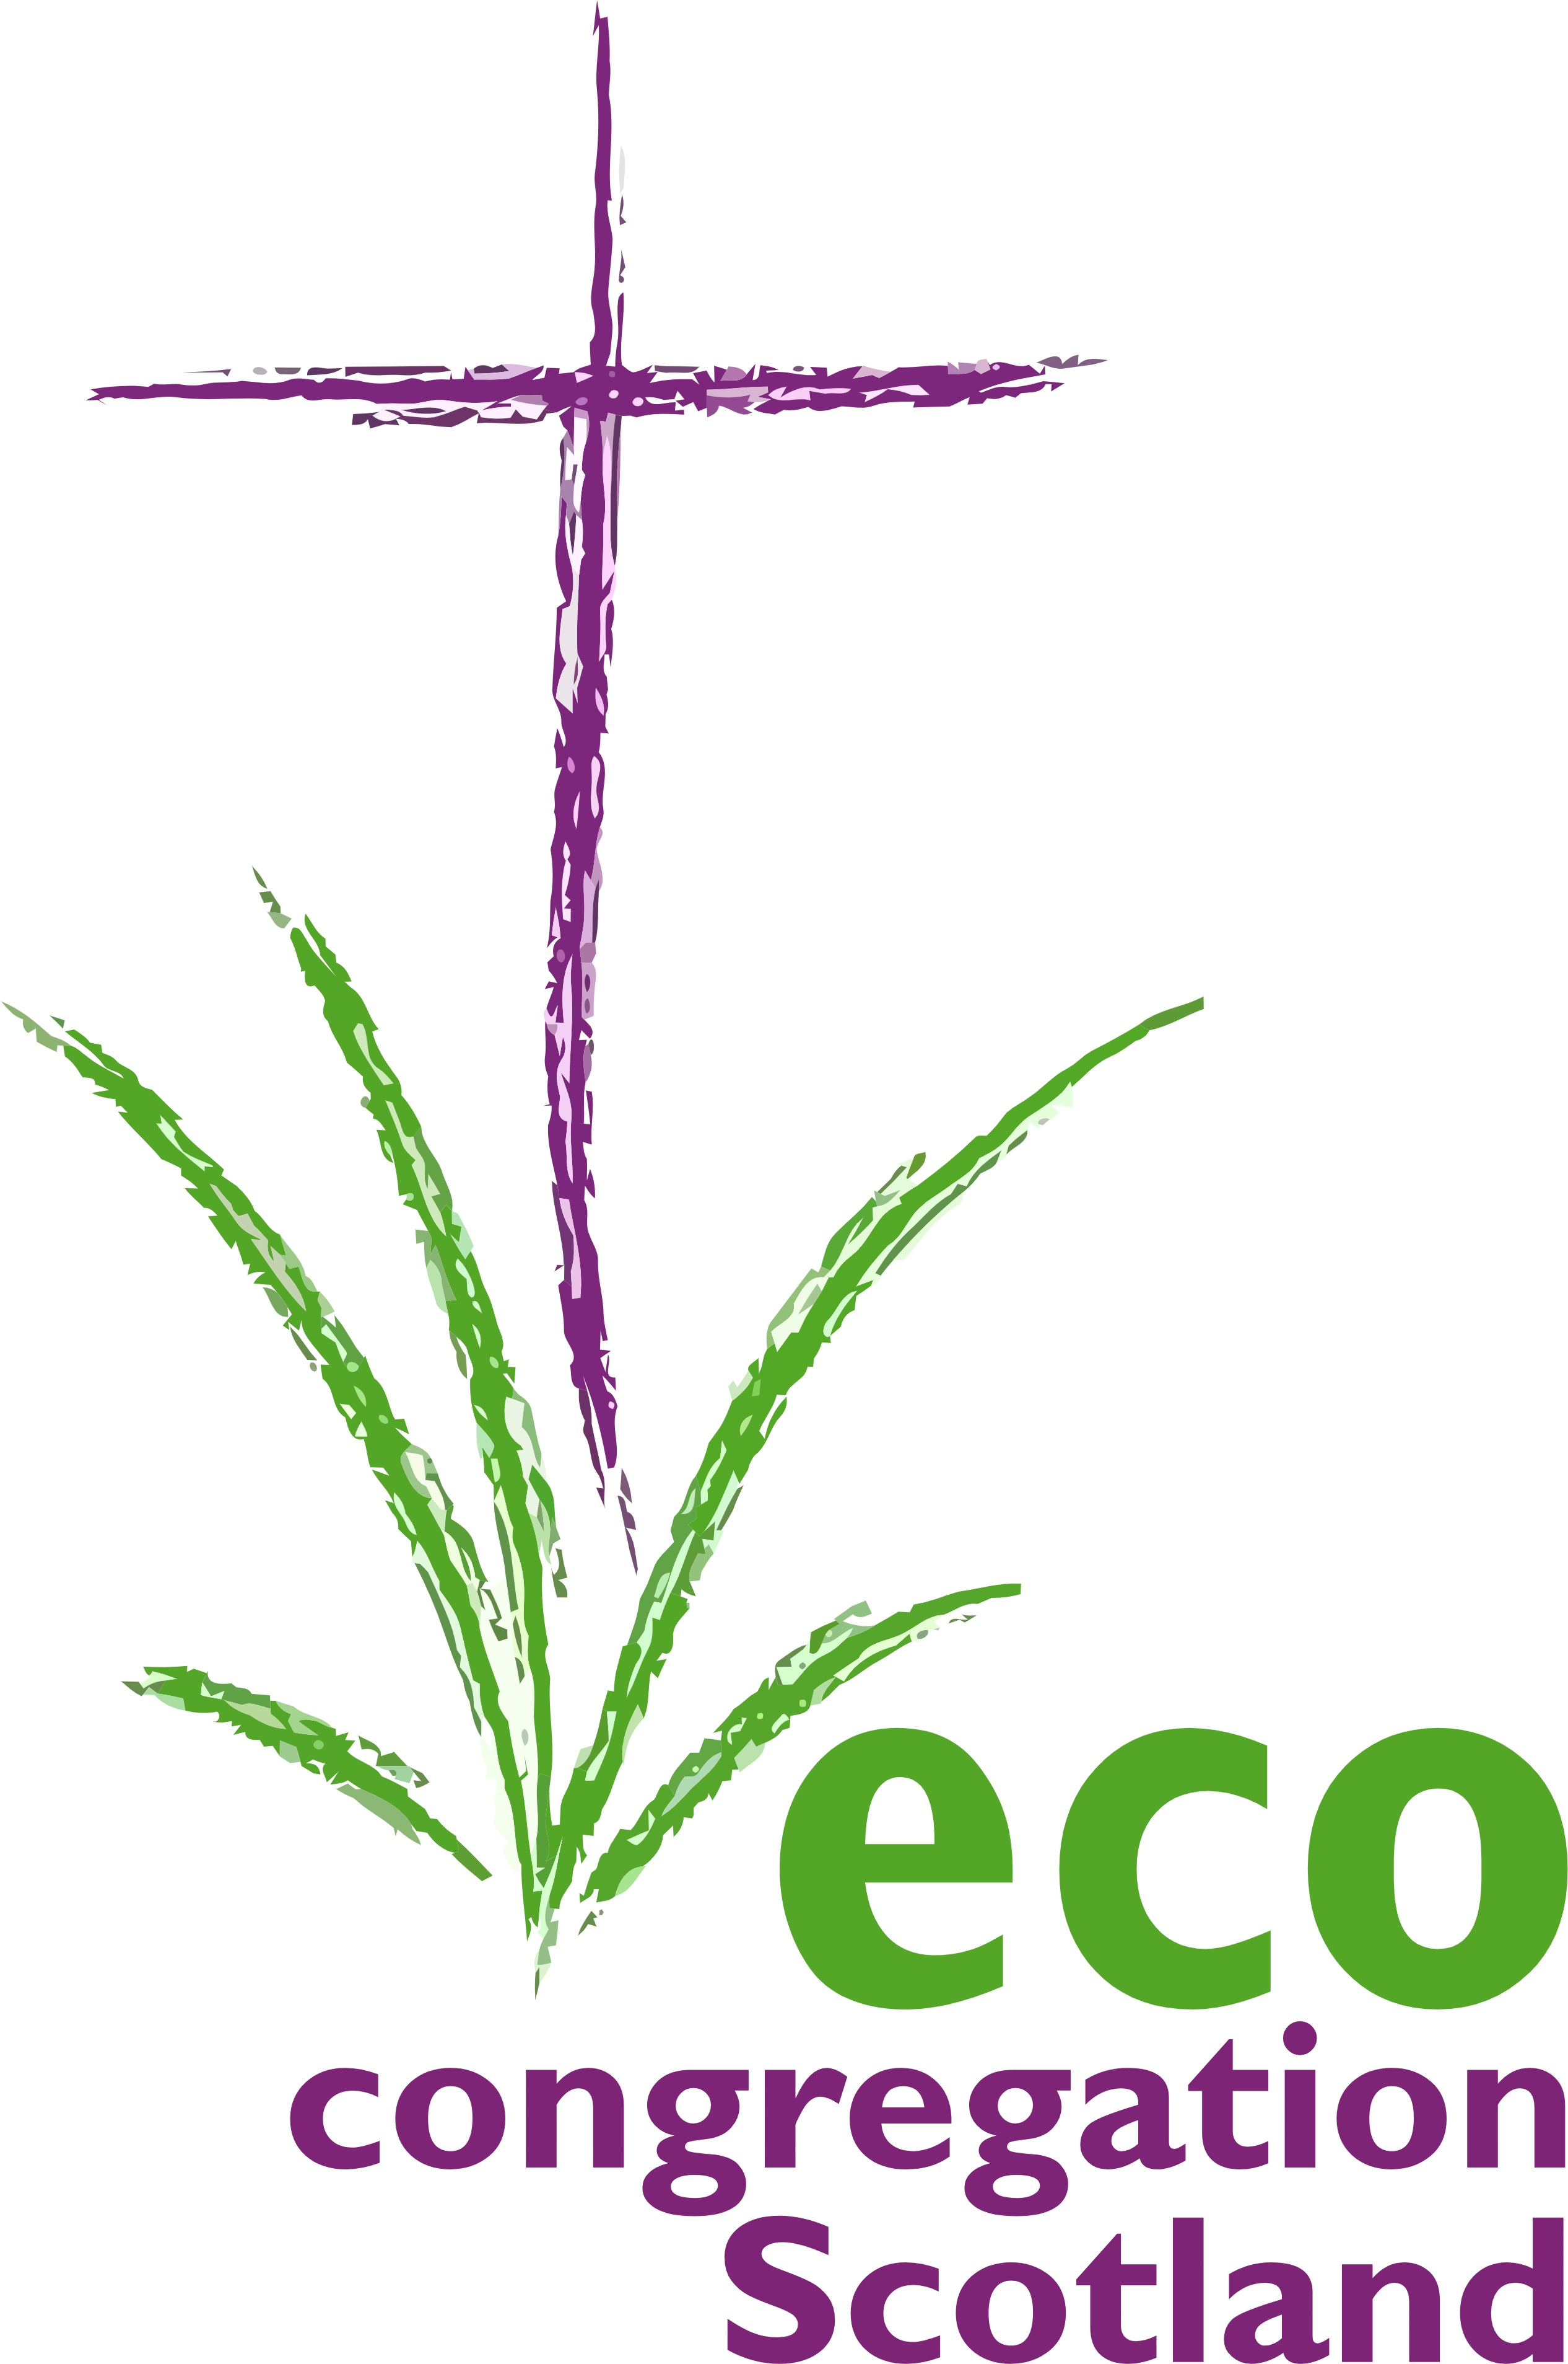

100 words today
Day 4:12th November:

Resilient Cities, Built Environment
Consider : The Repurposed City of God (Revelation 21:9-27) where health-giving biodiversity and abundant water supplies are built into a city, reshaped from what has been, to what surely yet can be. OR Jesus wept ( John 11:35) -Christ’s anguished love for the city that ignores God’s signs and warnings.
God with Us, God with Earth, bless with the justice of shade, the healing of trees and the refreshment of waters, all those great communities where people find both home and work in our day; that even as this crisis of nature and climate continues, which our species has knowingly perpetuated, our cities may unite to turn a corner of hope and resilience. In them may security and sanctuary join hands.

May our deepest needs both for beauty and nourishment be given highest priority, alongside shelter and prosperity for all who work that our cities may flourish by the preaching and living of your Gospel! AMEN

A reference to the city motto of Glasgow, location of COP26, where today a Mass is held for COP31

