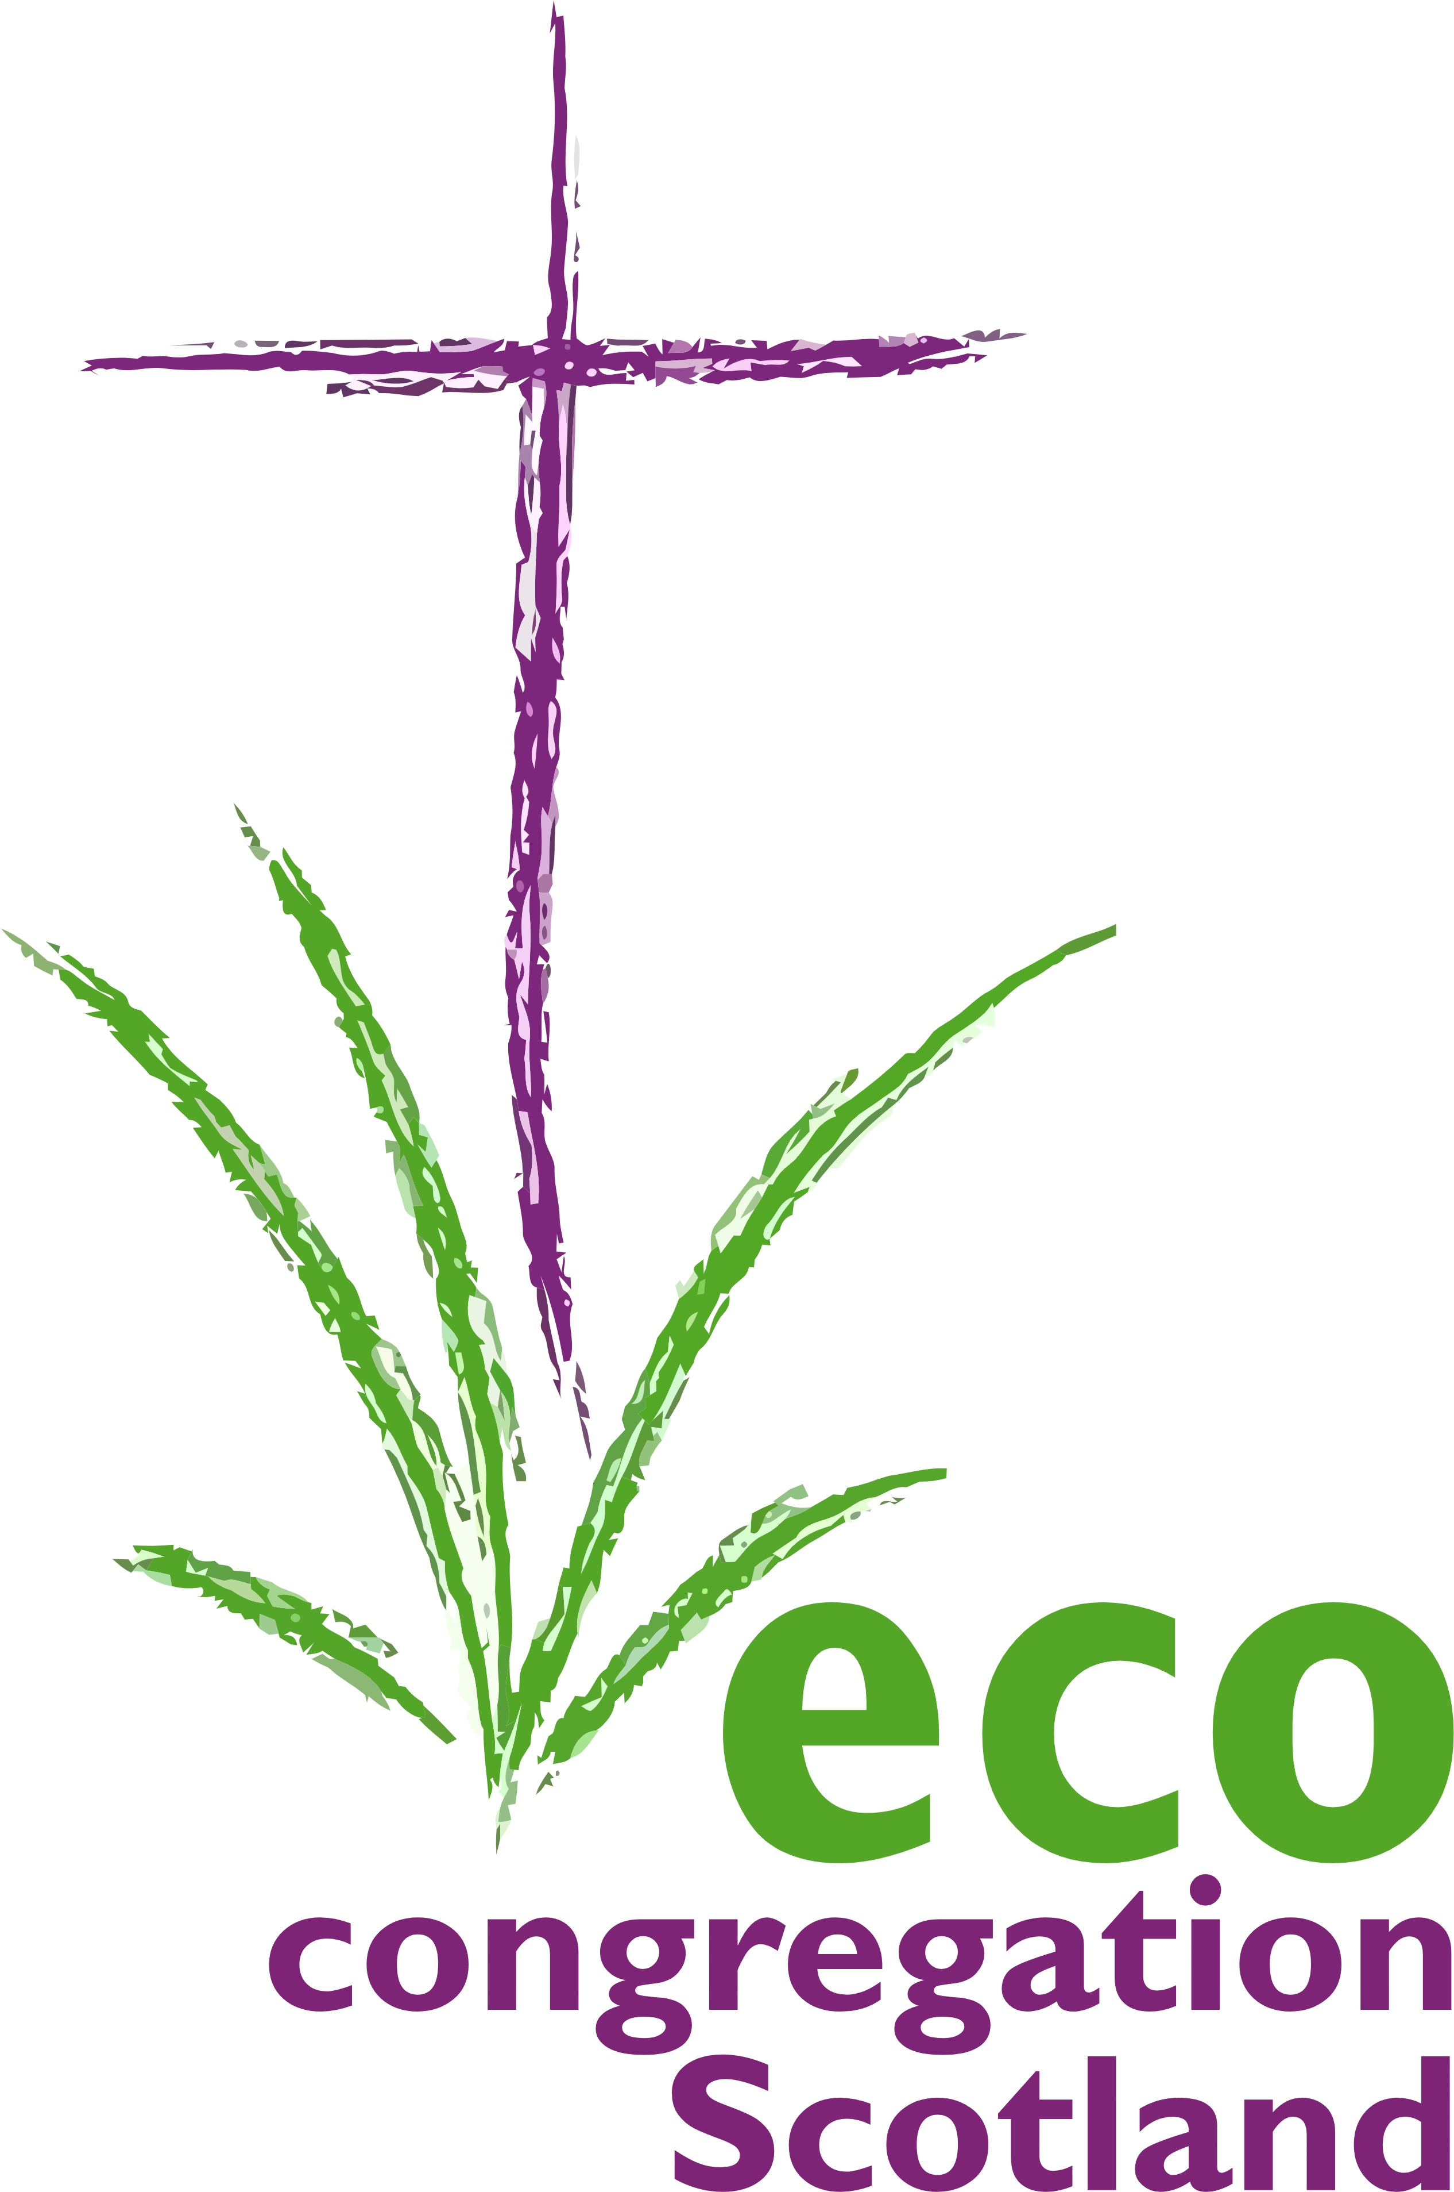

100 words today
Day 10:18th November:
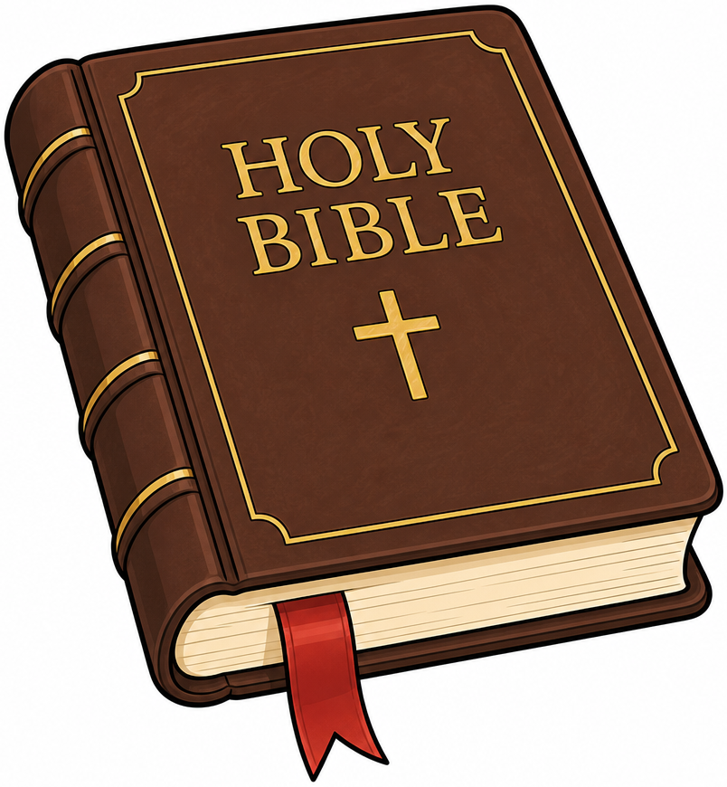
Human & Social Development
Consider : Blessed are the meek , they shall inherit the Earth (Matthew 5:5) OR The Rainbow Covenant (Genesis 9) Humanity as party to God’s Covenant with all life on Earth. OR Equality before God (Galatians 3:28 ) of all genders, races, social roles.
God: Holy Trinity, who lives and gives and shares;
Make us ever mindful of how gender justice; social equity, and peace between nations, go far beyond mere ‘worthy aims’.

For we have seen with clarity how such visions are a matter of the survival and flourishing of the life of your whole beloved Earth. Show us too, how care for Creation is inseparable from love for people, and save us from the satanic trap of setting these in false opposition.

Dear God, challenge, with your full authority, all amongst us who blame the poor for this crisis, even as we continue to burn and waste with profligacy what makes for a healthy planet. AMEN

