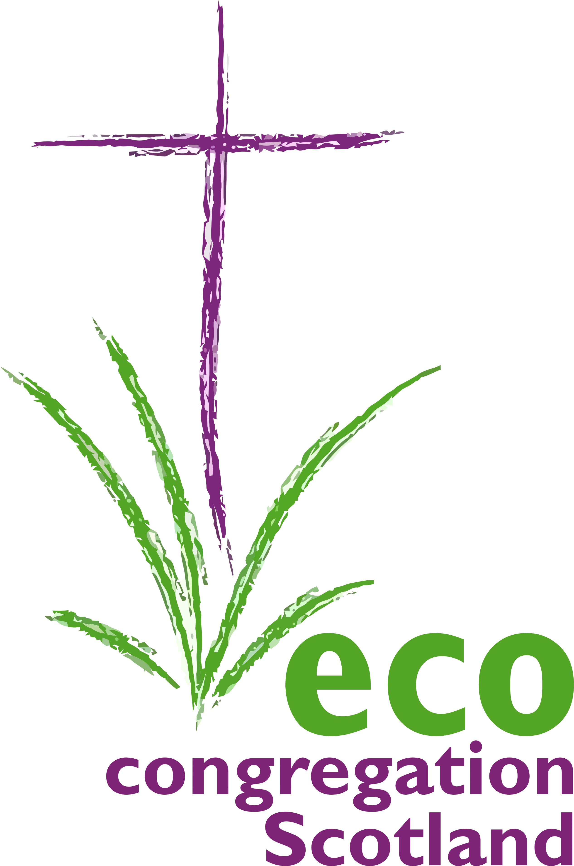
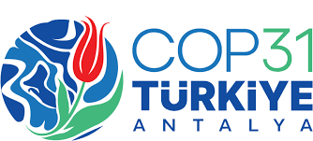
100 words today
Day 7:15th November:

social and cultural programmes Note: Antalya is an ancient settlement, with a cultural history stretching back millennia.
Consider : Peter’s vision of an affirmed diversity Acts 10: 9ff. Faced with the terrifying threats of the crisis of nature and climate, are we called to a fresh consideration of how God may be at work, for the good of all, in cultures and societies we may not have noticed or respected until now? OR Isaiah 51:2 “Look to the rock from which you were cut…” Cultural history can give a challenging perspective on who we are now.

God our Source, Guide and Goal,
We praise you with pretty things - you surround us with beauty;
We praise you with words - and your Word is made flesh;
We praise you with music, poetry, with all the arts - through which you raise deep questions.
You are not content to be a passive audience; indeed, from the Beginning, you dance, audaciously, with Creation in their entirety.

God beyond all cultures and traditions; cherish and foster in our nations whatever deepens communion with the Earth and fellow creatures.
May we always ‘test the spirits’; and delight, particularly, in the green wisdom discerned within indigenous cultures; in holy cultural gifts for resilience and healing. AMEN

