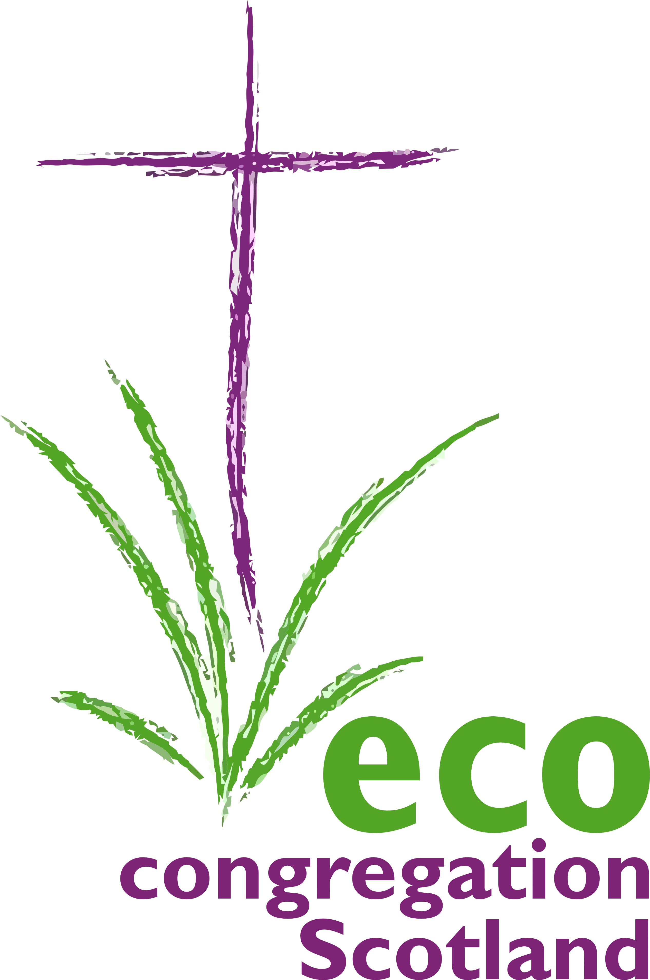

100 words today
Day 6:14th November:
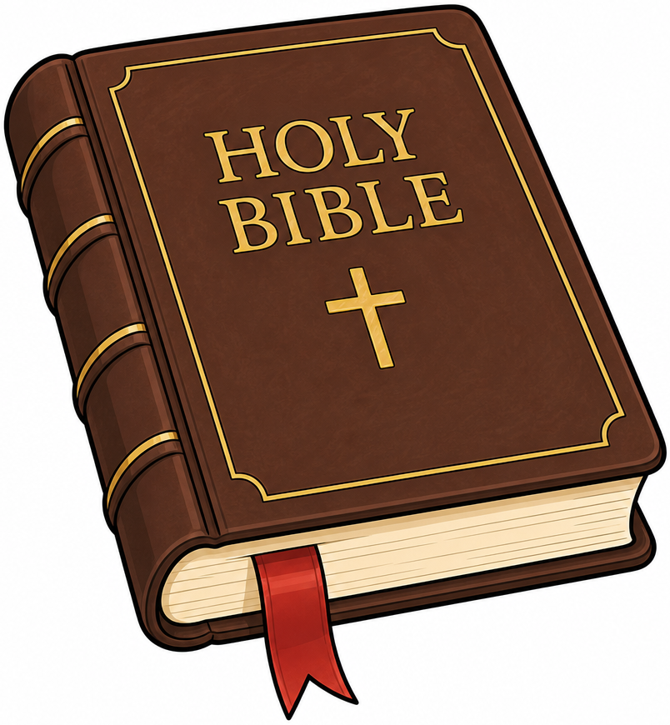
Children, Youth, Education & Skills
Consider : The child Jesus at the Temple Luke 2:41-52 - the questions of the young deserve good answers, that they may be ‘about our Father’s business’. OR ‘Let the little children come to me, …the kingdom of heaven belongs to such as these.’ Matthew 19:14. What is our responsibility to future generations?
Christ who, as a child learned both the skills of a trade and the love of your Word; who defended and respected the insights of the young.

Through our lives and by our prayers, may our senior generations encourage and empower our children; provoking them neither to anger nor despair, but rather to hope and committed action.

Christ who as an infant knew the terror and insecurity of a refugee family, we pray too for those displaced by war and climate crisis from their homelands and heritage.

God, our child, cry out and disturb every complacency of the adult world, which blunders on as if there were no other way. AMEN

