

100 words today
Day 5:13th November:
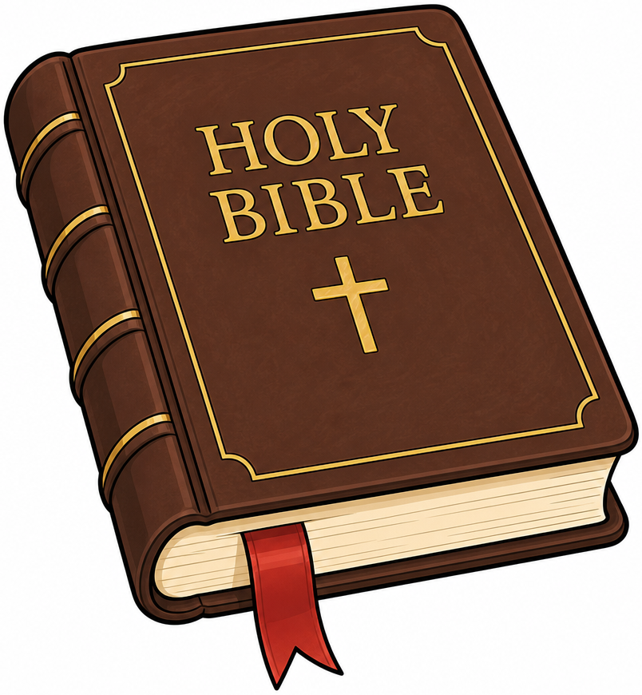
Finance and Trade
Consider : Much of Luke’s Gospel, but also Matthew 6:24 and Luke 16:13: You cannot serve both God and mammon. OR Parable of the Unforgiving Servant (Matthew 18:21–35) with implications for “Loss and Damage”.
God who, in the Cross of Christ, pays the price of sin; Christ who overturned the tables of those who traded unjustly: and called to account the idolatry of money, which should serve, not dictate, the welfare of the Earth’s diverse communities;

Bless all who engage in trade, mindful of justice for the Earth and all your beloved creatures. Challenge and remake our sense of what is valuable, that resources may be directed to those most in need, who have profited least from the injustice.

Challenge those who obstruct the flow of funds to respond to the crisis of nature and climate, and give us courage to speak out. AMEN

